Project: Woodson Park Academy & YMCA-ELC
Week Ending: August 9th, 2019

THIS WEEK:
- Demo crew to continue with demo
- Tree haul off continues
- Tire removal

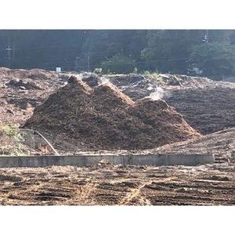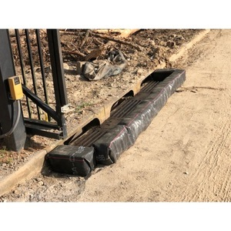

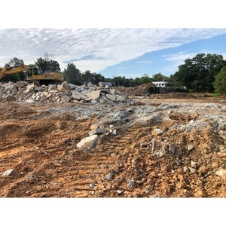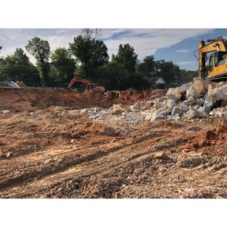

NEXT WEEK – August 12 thru August 16:
- Demo continues
- Storm drain structures to be delivered
- Mulch haul off
- Grading and utility to mobilize

PAYMENT STATUS:
- Gmp#1 $3,703,488.00
  - Paid to date amount $0.00
- GMP#2 $28,686,295.00
  - Paid to date amount $0.00

SCHEDULED DATE OF SUBSTANTIAL COMPLETION
- WPA – September 28, 2020
- YMCA-ELC - September 16, 2020

PREPARED BY:
- Matt Dauber, Carroll Daniel Construction Co.

